**[How does the new final rule differ from the rules that previously applied to construction work performed in confined spaces?](https://www.osha.gov/confinedspaces/faq.html" \l "collapse7" \o "How does the new final rule differ from the rules that previously applied to construction work performed in confined spaces?)**

The rule requires employers to determine what kinds of spaces their workers are in, what hazards could be there, how those hazards should be made safe, what training workers should receive, and how to rescue those workers if anything goes wrong.

**What is New or Different About the Construction Rule?**

There are 5 key differences from the construction rule, and several areas where OSHA has clarified existing requirements. The five new requirements include:

1. More detailed provisions requiring coordinated activities when there are multiple employers at the worksite (for more detail, [see question below](javascript:void();)). This will ensure hazards are not introduced into a confined space by workers performing tasks outside the space. An example would be a generator running near the entrance of a confined space causing a buildup of carbon monoxide within the space.
2. Requiring a competent person to evaluate the work site and identify confined spaces, including permit spaces.
3. Requiring continuous atmospheric monitoring whenever possible.
4. Requiring continuous monitoring of engulfment hazards. For example, when workers are performing work in a storm sewer, a storm upstream from the workers could cause flash flooding. An electronic sensor or observer posted upstream from the work site could alert workers in the space at the first sign of the hazard, giving the workers time to evacuate the space safely.
5. Allowing for the suspension of a permit, instead of cancellation, in the event of changes from the entry conditions list on the permit or an unexpected event requiring evacuation of the space. The space must be returned to the entry conditions listed on the permit before re-entry.

In addition, OSHA has added provisions to the new rule that clarifies existing requirements in the General Industry standard. These include:

1. Requiring that employers who direct workers to enter a space without using a complete permit system prevent workers’ exposure to physical hazards through elimination of the hazard or isolation methods such as lockout/tagout.
2. Requiring that employers who are relying on local emergency services for emergency services arrange for responders to give the employer advance notice if they will be unable to respond for a period of time (because they are responding to another emergency, attending department-wide training, etc.).
3. Requiring employers to provide training in a language and vocabulary that the worker understands.

Finally, several terms have been added to the definitions for the construction rule, such as "entry employer" to describe the employer who directs workers to enter a space, and "entry rescue", added to clarify the differences in the types of rescue employers can use.

**Do employers need to have a written confined space program?**

Yes if workers will enter permit spaces.

**Tell me more about the conversations between host employers, controlling contractors and entry employers**

The rule makes the controlling contractor, rather than the host employer, the primary point of contact for information about permit spaces at the work site. The host employer must provide information it has about permit spaces at the work site to the controlling contractor, who then passes it on to the employers whose employees will enter the spaces (entry employers). Likewise, entry employers must give the controlling contractor information about their entry program and hazards they encounter in the space, and the controlling contractor passes that information on to other entry employers and back to the host. As mentioned above, the controlling contractor is also responsible for making sure employers outside a space know not to create hazards in the space, and that entry employers working in a space at the same time do not create hazards for one another’s workers.

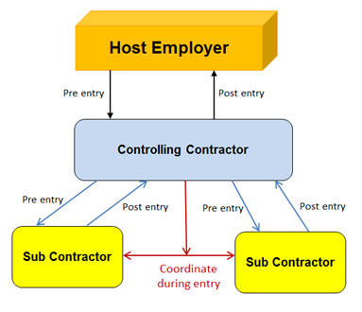

The above diagram shows the information flow and coordination between these employers

**What Standard should I follow if my workers are doing construction AND general industry work in confined spaces?**

An employer whose workers are engaged in both construction and general industry work in confined spaces will meet OSHA requirements if that employer meets the requirements of 29 CFR 1926 Subpart AA - Confined Spaces in Construction.

**When does the new rule go into effect?**

August 3, 2015

**Who does it apply to?**

Anyone entering confined spaces at construction sties.